#lab 2 ---> Machine Learning Techniques for Cyber Security
# ENSP355 | AI in Cyber Security
# ANJU 2401830009 Bsc(Hons)CyberSecurity
# Practical 1: Supervised ML for Intrusion Detection # Dataset: NSL-KDD (KDDTrain+.txt); this notebook creates an 80:20 stratified sp
import io, urllib.request, pandas as pd, numpy as np, matplotlib.pyplot as plt, from sklearn.model_selection import train_test_split
from sklearn.preprocessing import OneHotEncoder, StandardScaler, LabelEncoder from sklearn.compose import ColumnTransformer from sklearn.pipeline import Pipeline
from sklearn.metrics import classification_report, accuracy_score, confusion_mat from sklearn.tree import DecisionTreeClassifier from sklearn.ensemble import RandomForestClassifier from sklearn.svm import LinearSVC from sklearn.base import clone from time import perf_counter
COLUMNS = ['duration', 'protocol_type', 'service', 'flag', 'src_bytes', 'dst_byt
# Public GitHub mirror of the NSL-KDD text file. If this mirror is unavailable, # download KDDTrain+.TXT from an authorized NSL-KDD mirror and upload it to the URL = "https://raw.githubusercontent.com/defcom17/NSL_KDD/master/KDDTrain%2B.txt try:
raw = urllib.request.urlopen(URL, timeout=30).read() df = pd.read_csv(io.BytesIO(raw), header=None, names=COLUMNS) except Exception as exc: raise RuntimeError("Dataset download failed. Upload KDDTrain+.TXT and read i
print("Dataset shape:", df.shape) display(df.head()) print("\nMissing values:", int(df.isna().sum().sum())) print("\nLabel distribution:")
display(df["label"].value_counts().to_frame("records"))
# Binary target: normal versus attack. This avoids an extremely sparse multiclas # while preserving the core intrusion-detection task. df["target"] = (df["label"].astype(str).str.strip().str.lower() != "normal").ast plt.figure(figsize=(6,4)) df["target"].map({0:"Normal",1:"Attack"}).value_counts().plot(kind="bar") plt.title("NSL-KDD Class Distribution") plt.ylabel("Number of records") plt.xticks(rotation=0) plt.tight_layout() plt.show()
# Remove target-related columns from predictors. "difficulty" is dataset metadat X = df.drop(columns=["label", "difficulty", "target"], errors="ignore") y = df["target"] categorical = X.select_dtypes(include=["object"]).columns.tolist() numeric = X.select_dtypes(exclude=["object"]).columns.tolist() print("Number of input features:", X.shape[1]) print("Categorical features:", categorical) print("Numeric features:", len(numeric))
# Required 80:20 train-test split. Stratification keeps class proportions simila
X_train, X_test, y_train, y_test = train_test_split(
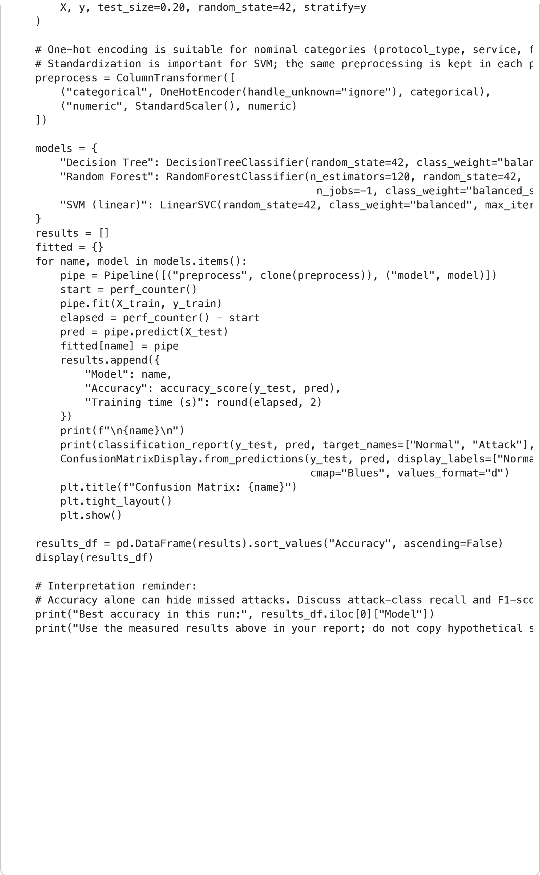

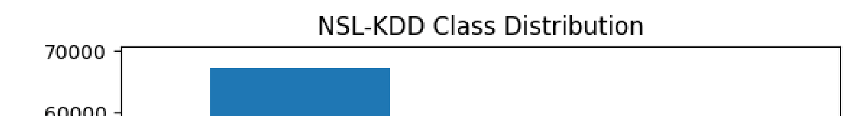
Dataset shape: (125973, 43)
duration
protocol_type
service
flag
src_bytes
dst_bytes
land
wrong_fragme
0
0
tcp
ftp_data
SF
491
0
0
1
0
udp
other
SF
146
0
0
2
0
tcp
private
S0
0
0
0
3
0
tcp
http
SF
232
8153
0
4
0
tcp
http
SF
199
420
0
5
rows × 43 columns
Missing values: 0
Label distribution:
records
label
normal
67343
neptune
41214
satan
3633
ipsweep
3599
portsweep
2931
smurf
2646
nmap
1493
back
956
teardrop
892
warezclient
890
pod
201
guess_passwd
53
buffer_overflow
30
warezmaster
20
land
18
imap
11
rootkit
10
loadmodule
9
ftp_write
8
multihop
7
phf
4
perl
3
spy
2
Number of input features: 41
Categorical features: ['protocol_type', 'service', 'flag']
Numeric features: 38 Decision Tree precision recall f1-score support
Normal 1.00 1.00 1.00 13469 Attack 1.00 1.00 1.00 11726
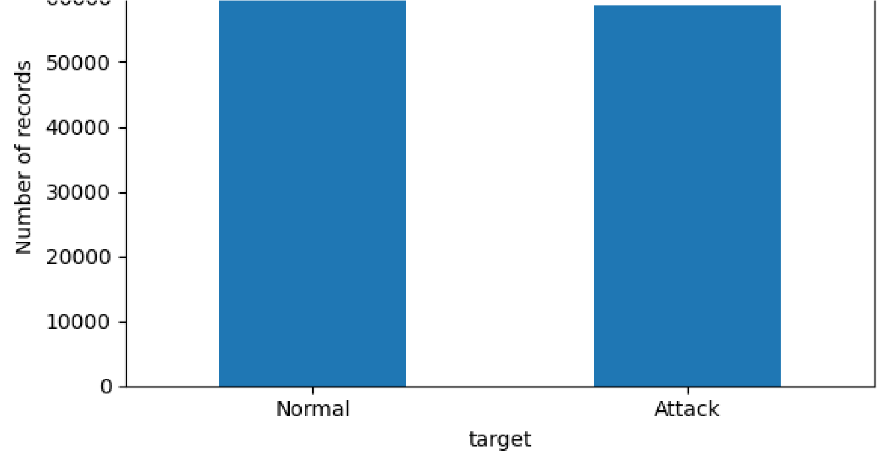
accuracy 1.00 25195 macro avg 1.00 1.00 1.00 25195 weighted avg 1.00 1.00 1.00 25195
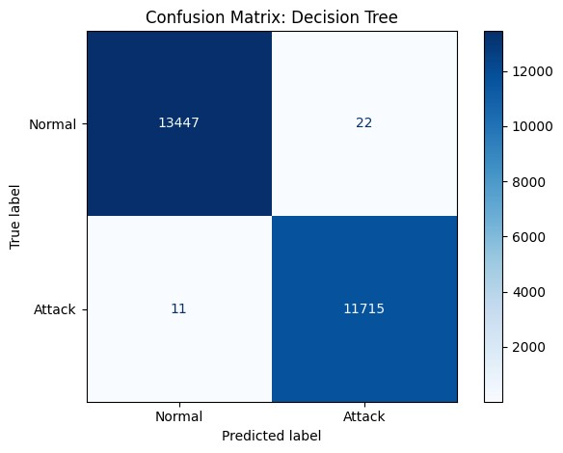
Random Forest precision recall f1-score support
Normal 1.00 1.00 1.00 13469
Attack 1.00 1.00 1.00 11726
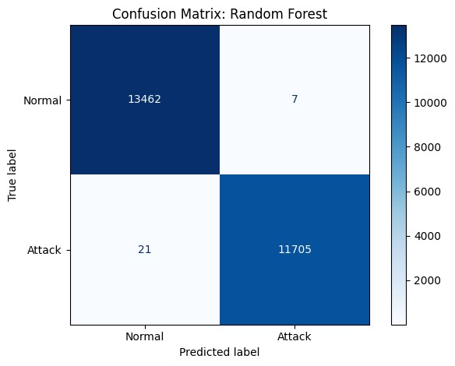
accuracy 1.00 25195
macro avg 1.00 1.00 1.00 25195
weighted avg 1.00 1.00 1.00 25195
SVM (linear)
precision recall f1-score support
Normal 0.97 0.98 0.98 13469 Attack 0.98 0.97 0.97 11726
accuracy 0.97 25195 macro avg 0.97 0.97 0.97 25195 weighted avg 0.97 0.97 0.97 25195
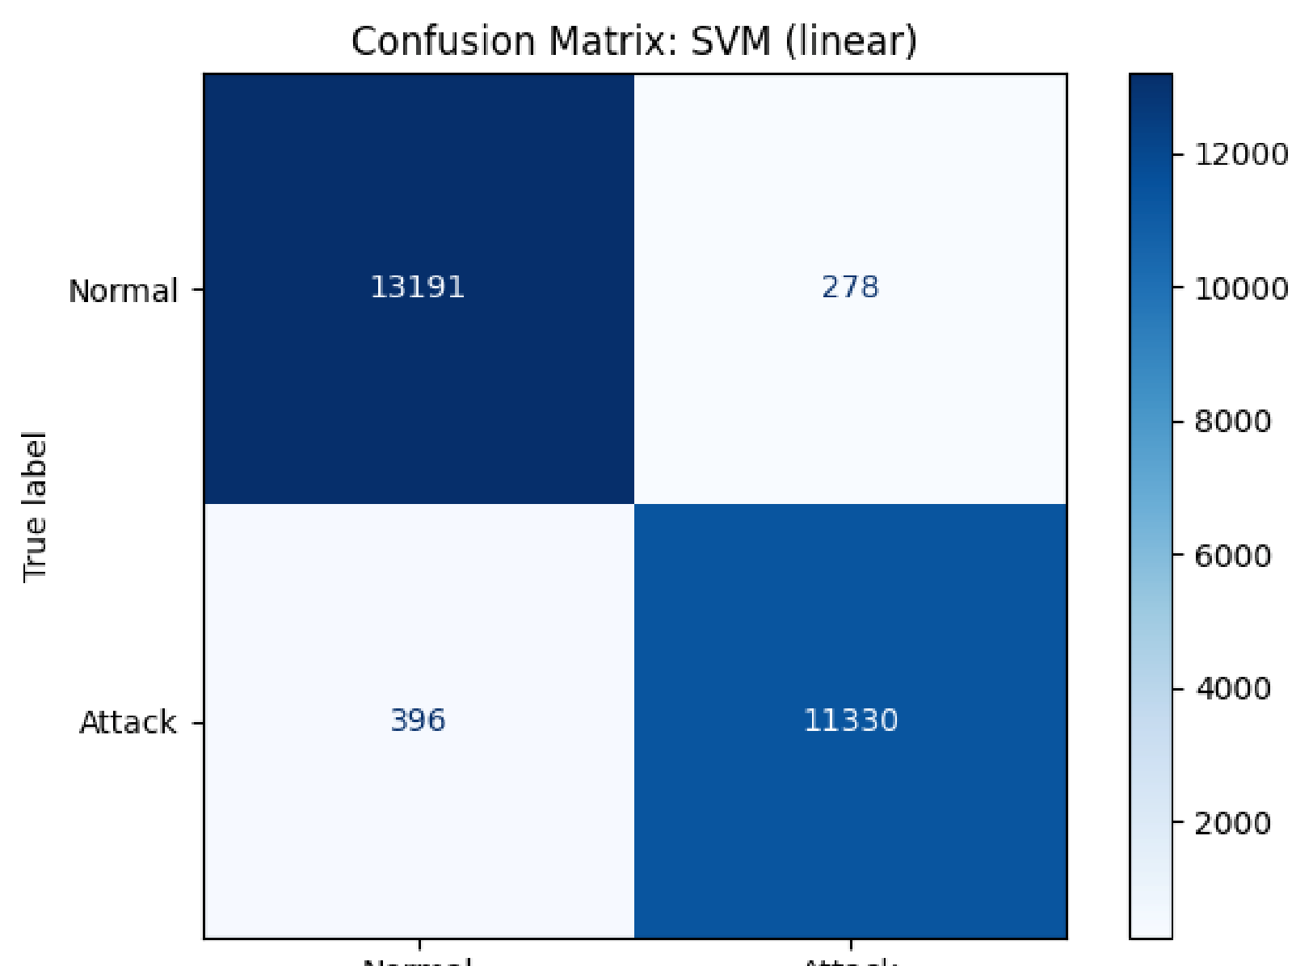
Next steps:
Generate code with
results_df
New interactive sheet

